Segment by segment, meter by meter, time has witnessed the world pioneer’s success. On the occasion of Chinese New year, an exciting news from came up Baicheng Railway site office that Menghua U-shape TBM has successfully completed the first 500 meters.
MENGHUA U-Sharp TBM made its first 500m successfully

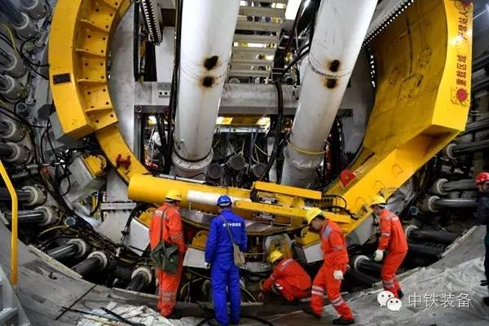
Baicheng Railway tunnel is located in Shanxi Province and had a total length of 3.345m with the maximum overburden 81,05m. The jobsite is in Quaternary alluvium, tunnel will be mainly built in silty sand, fine sand and yellowish clay. After enormous amount of demonstration and analysis, the World’s first U-shape EPB machine has been developed by CREG for the application of soft ground condition.
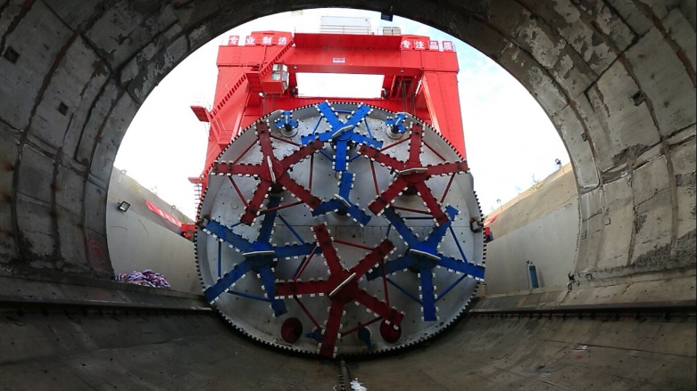
U-shape EPB machine was launched in Nov. 2016, according to the feedback from jobsite, it has well performed in soft ground mining. After an adaptation period, now they achieved high productivity of five rings per shift. Excavation parameters were registered and transferred to database center for further analysis.
U-shape TBM is about 110m long with a “horse shoe” section of 10.95m (width)*11.9m (height). The cutters are staggered fore and aft with partial overlap. This arrangement of multiple cutter heads covers 90% of the tunnel face; small edges are cut by the shield. Comparing with traditional TBM, U-shape TBM can reduce 10% to 15% excavation area so that it efficiently increase the section utilization.
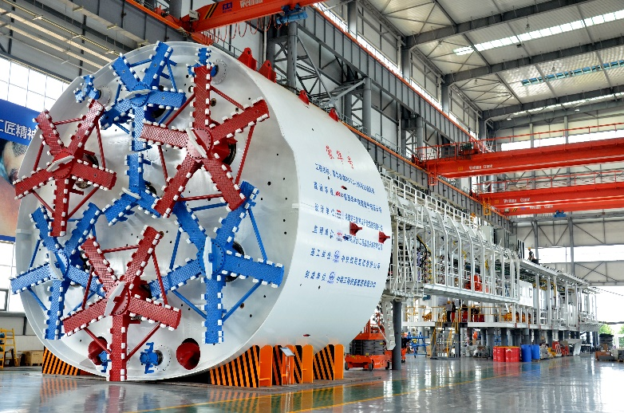
The main characters are as follow:
- Length of shield: 11 m
- Motorization: Electrical drive
- Drive power: 1.980 kw
- Max. thrust: 13.948 t
- Max. advance speed: 60 mm/min
- Max. torque: 2.643 kN∙m (per group)
- Min. turning curve: 800m
- Max. slope: 3%
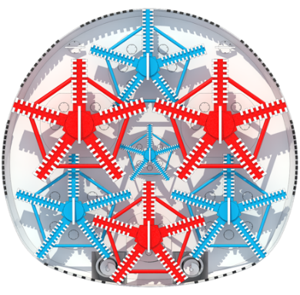
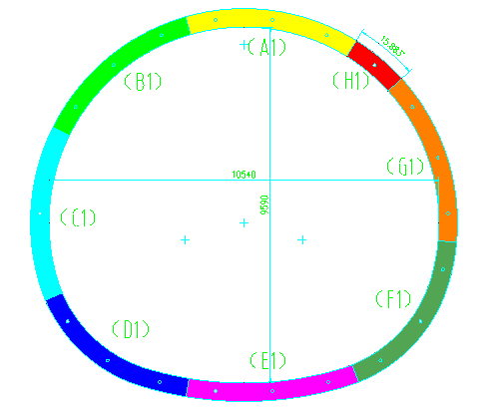
- Segment type 7+1

